DETAILS SPECIFICATION FOR HYGIENE KITS, HK
S/N | ITEMS | SECTOR SPECIFICATION | IMAGE
1. | Rubber hand gloves | Heavy duty protective work gloves, rubber, reusable, adult, size | 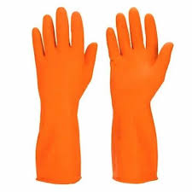
2. | Plastic Boots | Plastic boots/socks ( assorted, all adult size) | 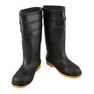
3. | Face/dust masks |  | 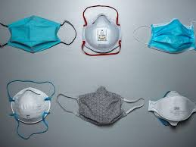
4. | Hats | For adult (Assorted, round type for field activities with GPON and NHF logos)
5. | Broom | Broom with soft handle
6. | Rake | Rake with iron handle | 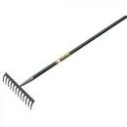
7. | Shovel | Shovel with iron handle | 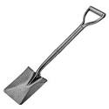
8. | Wheelbarrow | Wheelbarrow (reinforced, vesper type, regular wheelbarrow with a metal tray and solid wheels.) | 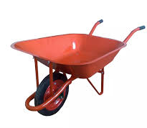
9. | Basic first-aid kits | For managing, cuts/ bruises include bandages, iodine, gauze, glove, plaster (adhesive) compress | 